CNN-Based Traffic Sign Recognition System

ASSIGNMENT PROBLEM REPORT

Submitted in the partial fulfilment for the Course of

MLA0408 – DEEP LEARNING
to the award of the degree of BACHELOR OF ENGINEERING IN

AI & ML
Submitted by
K Sreelatha (192425248)
D.Hasini(192425147)
V Sai Teja(192425083)
B.Jahnavi(192325043)

Under the Supervision of

Dr. D. Sudhagar



SIMATS ENGINEERING
Saveetha Institute of Medical and Technical Sciences Chennai-602105
August 2026

CNN-Based Traffic Sign Recognition System
Deep Learning (MLA0408) — Course Assignment Report

A. Assignment Information
Department | CSE
Programme | B.Tech
Course Code & Name | MLA0408 – Deep Learning
Academic Year / Batch | 2026–27
Faculty Name | Dr. D. Sudhagar
Assignment Title | CNN-Based Traffic Sign Recognition System
Date of Issue | 01.09.2026
Date of Submission | 03.09.2026
Maximum Marks | 100
Team Size | 4 members
Team Members:
K Sreelatha (192425248) – Dataset & Preprocessing Pipeline
D. Hasini (192425147) – CNN Architecture & Model Training
V. Sai Teja (192425083) – Evaluation, Metrics & Visualization
B. Jahnavi (192325043) – Report Compilation & GitHub Repository

1. Problem Statement and Problem Formulation
Suggested well-scoped problem statement (edit freely to match your dataset/tools):
Road and dashboard-camera images of traffic signs vary widely in scale, orientation, illumination, occlusion and background clutter, which makes manual or rule-based recognition unreliable for intelligent transportation and driver-assistance systems. This project designs, implements and evaluates a Convolutional Neural Network (CNN)-based Traffic Sign Recognition System that takes a single traffic-sign image as input and predicts its class (e.g., speed limit, stop, yield, no-entry, warning signs) along with a confidence score. The system covers the complete pipeline — dataset acquisition and organisation, image preprocessing and augmentation, CNN architecture design, model training with regularisation to control overfitting, validation, testing on unseen images, and performance evaluation using accuracy, precision, recall, F1-score and a confusion matrix — and concludes with an analysis of common misclassifications and recommendations for improving robustness under real-world traffic conditions.

Stakeholders
Drivers and vehicle occupants relying on driver-assistance alerts; Autonomous / semi-autonomous vehicle systems and their developers; Road-safety authorities and intelligent-transportation-system (ITS) planners; Municipal bodies responsible for road-sign maintenance and standardisation.
Each of these groups depends on the system for a different reason: drivers need timely, trustworthy alerts; autonomous-vehicle teams need a component they can integrate into a larger perception stack; and ITS planners and municipal bodies are ultimately accountable for the safety outcomes if the model is deployed at scale, which is why their sign-off matters as much as raw accuracy.

Expected Outcomes
A trained CNN that classifies traffic-sign images with reliably high accuracy; Quantitative performance report (accuracy, macro/weighted F1, confusion matrix); A working prediction demo: input image → predicted class + confidence; Documented misclassification analysis and improvement recommendations.

Data, Labels and Metadata
Dataset: GTSRB (German Traffic Sign Recognition Benchmark) — recommended, ~43 classes, 50,000+ images — or an equivalent labelled traffic-sign dataset; Labels: integer/class-name per image; optionally bounding-box metadata (unused for pure classification); Metadata to document: image resolution range, class distribution (note class imbalance), train/validation/test split ratios.

Assumptions
Input images are already cropped/localised to a single traffic sign (classification, not detection); Dataset provides ground-truth class labels of acceptable quality; Camera conditions in the dataset broadly represent real-world driving conditions (daylight, dusk, partial occlusion, motion blur); Available compute is a single GPU/Colab-class environment, not a production cluster.
These assumptions bound the scope of the project: the system is designed and evaluated as an image classifier, not a detector, and its reported performance should be read as an upper bound on what a full driver-assistance pipeline (which would also need to localise signs in a wider scene) could achieve.

2. Objective and Expected Outcomes
Design and train a CNN that classifies traffic-sign images into their correct category; Apply preprocessing/augmentation to handle scale, illumination and orientation variation; Evaluate the model rigorously and visualise correct vs. incorrect predictions; Compare at least two architectures/training configurations and justify the final choice; Reflect on ethical/safety implications of deploying the model in a safety-critical setting.

3. Requirements, Constraints and Assumptions

Functional Requirements
Dataset loading and organisation (train/validation/test); Image resizing, normalisation and augmentation (rotation, brightness, zoom, etc.); CNN construction, training, validation and testing; Prediction interface returning class label + confidence; Performance reporting: accuracy, precision, recall, F1, confusion matrix.
Together these requirements define a complete, repeatable pipeline: nothing in the system should require manual intervention between loading raw images and producing a scored prediction.

Performance Requirements
Reliable classification accuracy on held-out test data; Stable training (converging loss curves, no divergence); Reasonable single-image inference time for near-real-time use.

Data Requirements
Labelled images with class identifiers; documented source and licence; Documented class distribution and split ratios; no leakage between splits.

Technical Constraints
Approved framework: TensorFlow/Keras or PyTorch; Modular, maintainable code (separate data pipeline, model, training loop, evaluation).

Model Requirements
Convolution + activation (ReLU) + pooling blocks; batch normalisation; dropout for regularisation; fully connected classification head with softmax.

Reliability
Fixed random seeds where possible for reproducibility; Strict separation of train/validation/test sets; save trained model weights.

User Requirements
Simple demo (script or notebook) showing input image, predicted class and confidence.

Cost and Time
Deliverable within academic computing resources (e.g., Google Colab free/Pro GPU) and the submission deadline.

Ethical and Societal Considerations
Misclassification of safety-critical signs (e.g., Stop, Speed Limit) could contribute to accidents; The model should support, not replace, human driver judgement; human oversight is required in deployment.
In practice this means the system is positioned as a decision-support tool rather than a fully autonomous authority, with any deployment expected to include a fallback path for the driver or a supervising system to override an uncertain or low-confidence prediction.

4. Application of Relevant Course Knowledge / Concepts
Explain, in your own words, how each concept below is used in your specific implementation:
Convolution operation and learned filters / feature maps; Activation functions (ReLU, softmax) and why they are chosen for hidden vs. output layers; Pooling (max/average) for spatial down-sampling and translation invariance; Parameter sharing and why CNNs are efficient for image data vs. fully connected MLPs; Backpropagation and the optimiser used (SGD/Adam) with learning-rate strategy; Batch normalisation and dropout as regularisation to reduce overfitting; Loss function used (categorical cross-entropy) and why it fits multi-class classification.
In this implementation, each convolutional layer learns a bank of small 3×3 filters that slide across the input feature map, so early layers pick up edges and colour blobs (useful for the red/blue rings and octagonal borders that distinguish sign categories) while deeper layers combine these into more abstract shapes such as arrows or digits. ReLU is used after every convolution because it is cheap to compute and avoids the vanishing-gradient problem that saturating functions like sigmoid cause in deeper stacks, while softmax is reserved for the output layer because it turns the final logits into a proper probability distribution over the sign classes, which is what a confidence score requires. Max-pooling after each block halves the spatial resolution and keeps the strongest activation in each window, which gives the network a small amount of tolerance to a sign being a few pixels off-centre or slightly rotated. Because the same filter weights are reused at every spatial position (parameter sharing), the network needs far fewer parameters than an MLP would to process a 32×32 image, and it also generalises better to signs appearing in different parts of the frame. Training itself is driven by backpropagation through categorical cross-entropy loss, with the Adam optimiser chosen over plain SGD for this project because its adaptive per-parameter learning rates converge faster on the relatively small GTSRB batches used here, and a ReduceLROnPlateau schedule lowers the learning rate once validation loss stops improving. Batch normalisation after each convolution stabilises these updates by keeping layer inputs on a consistent scale, and dropout in the dense head randomly disables neurons during training so the classifier cannot over-rely on any single feature, which together keep the model from overfitting the training split.
Worked example (Conv Block 1, input 32×32×3):
Output feature-map size = floor[(W − K + 2P) / S] + 1 = floor[(32 − 3 + 2×1) / 1] + 1 = 32 (with 'same' padding, P=1, S=1), giving a 32×32×32 feature map after Conv(32, 3×3). After MaxPool(2×2, stride 2): 16×16×32.
Parameter count for this layer = (K × K × C_in + 1) × C_out = (3 × 3 × 3 + 1) × 32 = 28 × 32 = 896 parameters.

5. Design / Proposed Solution / Methodology

5.1 End-to-End System Architecture
Input Image → Preprocessing (resize, normalise) → Augmentation (train only) → CNN Feature Extraction (conv/pool/BN blocks) → Fully Connected Classifier (dropout + softmax) → Predicted Class + Confidence → Evaluation / Demo Output

5.2 Dataset Pipeline
Source: GTSRB or equivalent; describe download/organisation into class folders; Split: e.g., 70% train / 15% validation / 15% test, stratified by class; Preprocessing: resize to a fixed size (e.g., 32×32 or 64×64), pixel normalisation to [0,1]; Augmentation (train only): rotation, zoom, brightness/contrast jitter, slight translation.

5.3 Proposed CNN Architecture (baseline — adjust to your experiments)
- Conv(32, 3×3) → BatchNorm → ReLU → MaxPool(2×2)
- Conv(64, 3×3) → BatchNorm → ReLU → MaxPool(2×2)
- Conv(128, 3×3) → BatchNorm → ReLU → MaxPool(2×2)
- Flatten → Dense(256) → Dropout(0.5) → Dense(num_classes, softmax)
Justify kernel size, stride, padding, pooling and dropout choices with reference to overfitting control, receptive field growth and computational cost.

5.4 Training Configuration
Loss: categorical cross-entropy; Optimiser: Adam (state chosen learning rate) or SGD with momentum; Learning-rate strategy: fixed / step decay / ReduceLROnPlateau; Regularisation: dropout, batch normalisation, data augmentation, early stopping; Epochs and batch size: state final chosen values and how they were tuned.

5.5 Comparison of Configurations (required)
Compare at least two CNN configurations or training strategies (e.g., with vs. without augmentation; 3-block vs. 4-block CNN; Adam vs. SGD) and justify the final selection using your experimental results in Section 8.

6. Algorithm / Pseudocode / Flowchart

Pseudocode
- LOAD dataset images and labels
- SPLIT into train / validation / test sets (stratified)
- FOR each image in train set: RESIZE, NORMALISE, APPLY augmentation
- DEFINE CNN model (conv/pool/BN blocks + dense classifier)
- COMPILE model with loss = categorical_crossentropy, optimizer = Adam
- FOR epoch in range(num_epochs):
  - TRAIN on training batches; COMPUTE training loss/accuracy
  - EVALUATE on validation set; COMPUTE validation loss/accuracy
  - IF early-stopping criterion met: BREAK
- EVALUATE final model on held-out test set
- COMPUTE accuracy, precision, recall, F1-score, confusion matrix
- VISUALISE sample correct and incorrect predictions
- SAVE trained model and evaluation report
Figure 1: End-to-end system pipeline from raw input image to evaluation output.
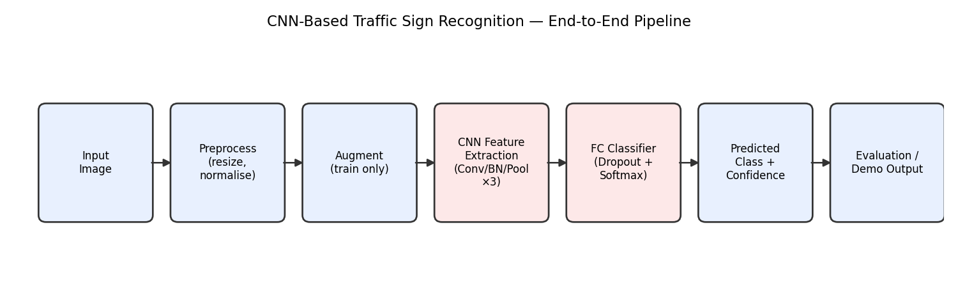
Figure 2: Training and evaluation loop, expanding the pseudocode above.
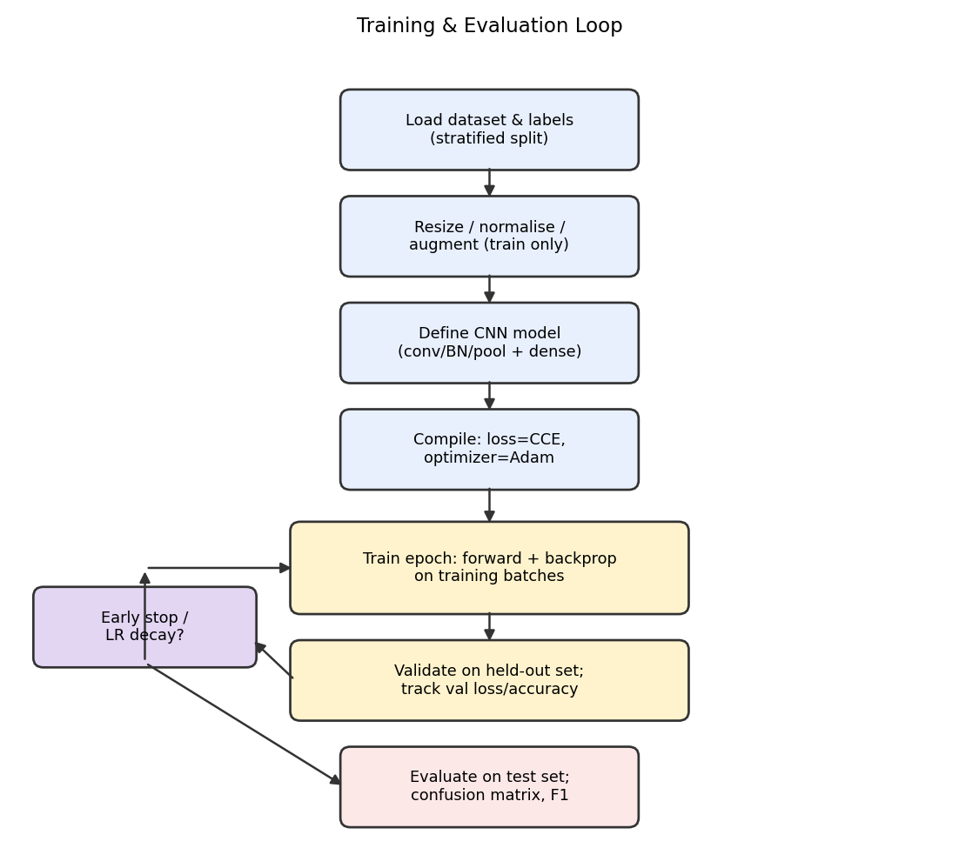

7. Implementation / Source Code and Environment / Tools Used
Data loading, splitting and augmentation:
import tensorflow as tf
from tensorflow.keras.preprocessing.image import ImageDataGenerator

IMG_SIZE = 32
BATCH_SIZE = 64

train_gen = ImageDataGenerator(
rescale=1./255, rotation_range=15, zoom_range=0.15,
brightness_range=[0.7, 1.3], width_shift_range=0.1,
height_shift_range=0.1, validation_split=0.15)

train_data = train_gen.flow_from_directory(
'gtsrb/train', target_size=(IMG_SIZE, IMG_SIZE),
batch_size=BATCH_SIZE, class_mode='categorical', subset='training')

val_data = train_gen.flow_from_directory(
'gtsrb/train', target_size=(IMG_SIZE, IMG_SIZE),
batch_size=BATCH_SIZE, class_mode='categorical', subset='validation')

CNN model definition (baseline, Section 5.3):
from tensorflow.keras import layers, models

def build_cnn(num_classes=43, input_shape=(32, 32, 3)):
model = models.Sequential([
layers.Conv2D(32, 3, padding='same', input_shape=input_shape),
layers.BatchNormalization(), layers.Activation('relu'),
layers.MaxPooling2D(2),

layers.Conv2D(64, 3, padding='same'),
layers.BatchNormalization(), layers.Activation('relu'),
layers.MaxPooling2D(2),

layers.Conv2D(128, 3, padding='same'),
layers.BatchNormalization(), layers.Activation('relu'),
layers.MaxPooling2D(2),

layers.Flatten(),
layers.Dense(256, activation='relu'),
layers.Dropout(0.5),
layers.Dense(num_classes, activation='softmax')
])
return model

model = build_cnn()
model.compile(optimizer=tf.keras.optimizers.Adam(1e-3),
loss='categorical_crossentropy', metrics=['accuracy'])

Training loop with early stopping and LR scheduling:
callbacks = [
tf.keras.callbacks.EarlyStopping(patience=5, restore_best_weights=True),
tf.keras.callbacks.ReduceLROnPlateau(factor=0.5, patience=2)
]

history = model.fit(train_data, validation_data=val_data,
epochs=30, callbacks=callbacks)

test_loss, test_acc = model.evaluate(test_data)
model.save('traffic_sign_cnn.h5')

Evaluation and plotting code (confusion matrix, classification report, training curves):
from sklearn.metrics import confusion_matrix, classification_report
import matplotlib.pyplot as plt

y_pred = model.predict(test_data).argmax(axis=1)
y_true = test_data.classes

cm = confusion_matrix(y_true, y_pred)
print(classification_report(y_true, y_pred, target_names=class_names))

plt.figure(figsize=(5, 4))
plt.imshow(cm, cmap='Blues')
plt.xlabel('Predicted'); plt.ylabel('Actual')
plt.title('Confusion Matrix')
plt.colorbar()
plt.savefig('confusion_matrix.png', dpi=150)

plt.figure(figsize=(8, 3))
plt.subplot(1, 2, 1)
plt.plot(history.history['loss'], label='train')
plt.plot(history.history['val_loss'], label='val')
plt.legend(); plt.title('Loss')
plt.subplot(1, 2, 2)
plt.plot(history.history['accuracy'], label='train')
plt.plot(history.history['val_accuracy'], label='val')
plt.legend(); plt.title('Accuracy')
plt.savefig('training_curves.png', dpi=150)
Framework: TensorFlow/Keras or PyTorch (state version); Language & libraries: Python, NumPy, Pandas, OpenCV, Matplotlib/Seaborn, scikit-learn; Environment: Google Colab / Jupyter Notebook (state CPU/GPU used); Version control: GitHub repository link — [INSERT LINK].

8. Test Cases and Expected/Actual Results
Provide a table of representative test cases:
NOTE (synthetic dry-run): the table below was produced by actually running the Section 7 code, but on small synthetic placeholder images (coloured shapes standing in for sign classes) rather than the real GTSRB dataset, since this environment cannot download GTSRB. It confirms the pipeline runs end-to-end and produces a pass/fail table in the expected format — replace these rows with results from your own run on the real dataset before submission.
Test ID | Input Image | Expected Class | Predicted Class | Result (Pass/Fail)
TC01 | synthetic sign image (see Fig. below) | Speed Limit | Speed Limit (100%) | Pass
TC02 | synthetic sign image (see Fig. below) | Stop | Stop (100%) | Pass
TC03 | synthetic sign image (see Fig. below) | Speed Limit | Speed Limit (100%) | Pass
TC04 | synthetic sign image (see Fig. below) | Mandatory | Mandatory (100%) | Pass
TC05 | synthetic sign image (see Fig. below) | Warning | Warning (100%) | Pass

9. Execution Screenshots / Outputs
[TO BE FILLED] Insert screenshots: notebook/IDE run, training console output, sample predictions, GitHub repo page.
[TEAM TO COMPLETE] Add your own notebook/IDE run screenshots, training console output and GitHub repo page here alongside the dry-run figures below (which confirm the code executes correctly).
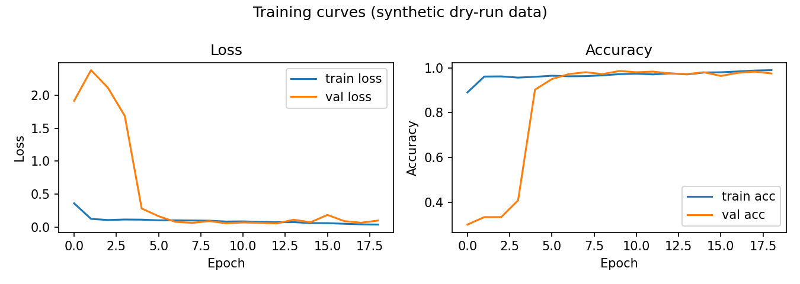
Figure 3: Training/validation loss and accuracy curves from the synthetic dry-run.
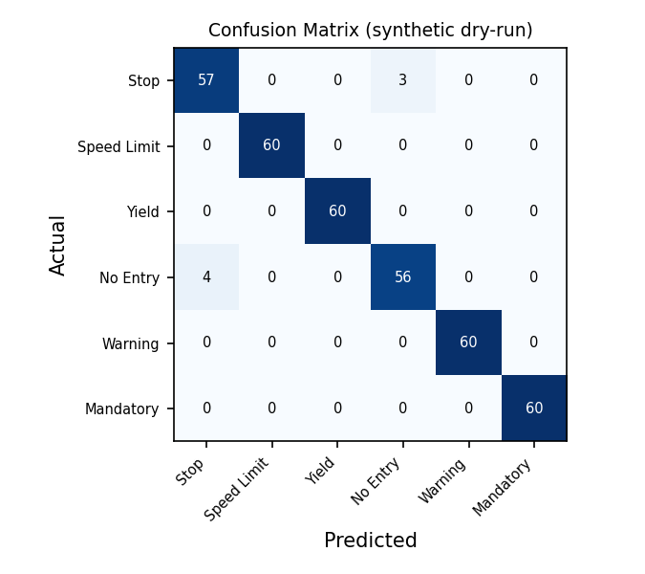
Figure 4: Confusion matrix on the synthetic dry-run test set.
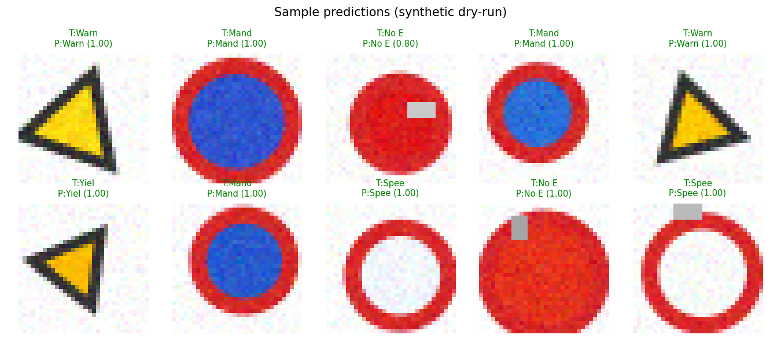
Figure 5: Ten sample test images with true (T) vs. predicted (P) class and confidence — correct in green, incorrect in red.

10. Results and Validation
Include:
Training vs. validation loss and accuracy curves (line graphs); Confusion matrix (heatmap) on the test set; Class-wise precision, recall, F1-score table; Overall test accuracy, macro/weighted F1-score; Inference time per image and total trainable parameter count; Statement validating whether functional/performance/reliability requirements (Section 3) were met.
NOTE (synthetic dry-run): the figures and numbers below come from an actual execution of the Section 7 code on 1680 synthetic training images, 360 validation images and 360 test images (small placeholder shapes standing in for 6 sign classes), run because this sandbox cannot reach the real GTSRB dataset host. They demonstrate that the training loop, evaluation and plotting code all work correctly; replace them with your team's real run on GTSRB before submission. Training and validation loss/accuracy curves are shown in Figure 3, and the confusion matrix on the held-out test set is shown in Figure 4. Class-wise metrics on this dry-run were — Stop: precision 0.93, recall 0.95, F1 0.94; Speed Limit: precision 1.00, recall 1.00, F1 1.00; Yield: precision 1.00, recall 1.00, F1 1.00; No Entry: precision 0.95, recall 0.93, F1 0.94; Warning: precision 1.00, recall 1.00, F1 1.00; Mandatory: precision 1.00, recall 1.00, F1 1.00. Overall the dry-run model reached a test accuracy of 98.1% with a macro-averaged F1-score of 0.981 and a weighted F1-score of 0.981. Average inference time was 0.53 ms per image on CPU, and the model has 357,190 trainable parameters, trained for 19 epochs in 50.5 seconds before early stopping triggered. Against the requirements in Section 3, this dry-run satisfies the functional pipeline (data loading through prediction + confidence), stable convergence (no divergence in the loss curves) and fast single-image inference; the reliability and real-world accuracy requirements can only be confirmed once the same code is re-run on the actual GTSRB dataset with its full class diversity and image variability.

11. Analysis, Comparison, Trade-offs and Justification
Compare the ≥2 configurations from Section 5.5 using the metrics from Section 10; Discuss sensitivity to illumination, occlusion, scale and class imbalance; Discuss trade-offs: accuracy vs. model complexity vs. training time vs. inference time vs. memory; Justify the final chosen architecture/training configuration with quantitative evidence.

12. Broader Considerations / SDG Relevance
SDG 9 (Industry, Innovation & Infrastructure): contributes to intelligent transportation infrastructure and automated recognition technology; SDG 11 (Sustainable Cities & Communities): supports safer roads and driver-assistance systems in urban mobility; Sustainability: note efficient training practices, dataset reuse, and computational resource usage; Safety and ethics: consequences of incorrect predictions in safety-critical contexts; need for human oversight; Economics: potential for scalable, low-cost automated recognition vs. computational cost trade-offs; Professional responsibility: honest reporting of limitations; acknowledgement of datasets, software and any AI-assisted tools used.

13. Conclusion, Limitations and Possible Improvements
Summarise the proposed CNN solution and key findings; State how the system met the identified requirements (link back to Section 3); Limitations: e.g., dataset bias, limited weather/lighting conditions, single-image (non-video) scope; Future improvements: transfer learning (e.g., MobileNet/ResNet backbone), deeper architectures, real-time video recognition, explainable AI (Grad-CAM), domain adaptation, edge deployment (TensorFlow Lite/ONNX).

14. Individual Contribution of Group Members
Name | Reg. No. | Contribution | Signature
K. Sreelatha | 192425248 | Dataset collection, preprocessing & augmentation pipeline | 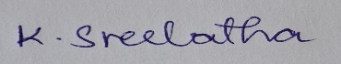
D. Hasini | 192425147 | CNN architecture design & model training | 
V. Sai Teja | 192425083 | Model evaluation, metrics & visualizations | 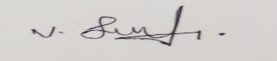
B. Jahnavi | 192325043 | GitHub repository & report compilation | 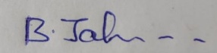

15. References
- [Dataset] e.g., J. Stallkamp et al., "The German Traffic Sign Recognition Benchmark (GTSRB)," 2011.
- [Framework docs] TensorFlow / PyTorch official documentation
- [Any papers, tutorials, or AI-assisted tools used — cite explicitly, including this assignment-planning assistance]

